TECHNICAL SPECIFICATION© ISO 2001 – All rights reservedISO/TS 13499:2001(E) 27 Road vehicles — Multimedia data exchange format for impact testsVéhicules routiers — Format d'échange de données multimédia pour les essais de chocRoad vehicles — Multimedia data exchange format for impact testsE2001-10-11(60) PublicationISOISO Technical Specification ISO/TS 13499ISO/TS 13499ISO 13499:2001(E) AFNOR Road vehicles31222 2Titre 2Titre 1 Fr1 Preview release 3STD Version 2.060 4\SERV_CESPA\02\_BNA\XDOM001\ISO\ISO\ISO_TS13499_(E).doc ISO TC 22/SC 36
Date: 2026-07-11
ISO/TS 13499 – RED F : 2026(E)
ISO TC 22/SC 36/WG 3
Secretariat: AFNOR

Road vehicles — Multimedia data exchange format for impact tests
Véhicules routiers — Format d'échange de données multimédia pour les essais de choc

Related electronic document F

Active Safety Recommendation

Rev 20260711

Contents Page
1 Normative references 4
2 Hints 4
3 MME Descriptors 4
3.1 Remarks to MME descriptors for active safety 4
3.2 Additional MME descriptors for active safety 4
3.3 MME Attribute Values 7
3.3.1 Test object 7
3.3.2 System Function 7
3.3.3 Scenario 8
3.3.4 Test Campaign Type 9
3.3.5 Type of the test 10
3.3.6 Subtype of the test 10
3.3.7 Regulation 11
3.3.8 Name of test object X 11
3.3.9 Vehicle Shape and Vehicle Dimension 12
3.3.10 Impact locations, heading and side definitions 12
3.3.11 Robustness Layer 13
4 Reference Coordinate Systems 15
4.1 Vehicle Coordinate System 16
4.2 Test Ground Coordinate System 16
5 Channel Codes 17
5.1 Enhancement for specific Main and Fine Locations for active safety 17
5.1.1 Additional Main Locations 17
5.1.1.1 Function based Main Locations 17
5.1.1.2 Main Location for distances between test objects 18
5.1.1.3 Main Locations for Vulnerable Road Users 18
5.1.1.4 Naming of Bus Signals 19
5.1.2 Additional Fine Locations 19
5.1.2.1 Fine Location 1 19
5.1.2.2 Fine Location 2 20
5.1.2.3 Fine Location 3 20
5.2 Channel codes for function based channels 20
5.2.1 TTC 20
5.2.2 Calculated vs. vehicle communication bus channels 21
5.3 Channel codes for distances 21
5.3.1 C2C distance channels 23
5.3.1.1 CCRs, CCRm, CCRb 23
5.3.1.2 CCFtap 23
5.3.2 VRU distance channels 24
5.3.2.1 Nearside, Farside, Longitudinal 24
5.3.2.2 Turning, Reverse 24
5.3.3 LSS distance channels 24
5.3.4 BSD distance channels 25
5.3.4.1 Overtaking 25
5.3.4.2 Merging 25
5.3.5 Path Error distance channels 26
5.3.5.1 VUT longitudinal path error 26
5.3.5.2 VUT lateral path error 27
5.3.6 Examples 27
5.4 Codes for Test Type C2C 28
5.5 Codes for Test Type VRU 30
5.6 Codes for Test Type LSS 32
5.7 Codes for Test Type DOW 32
6 Examples 34
6.1 Examples for MME 1.6 34
6.1.1 Example of a test information file MME 1.6 34
6.1.2 Example of a channel information file MME 1.6 36
6.1.3 Example of a channel data file MME 1.6 36
6.2 Examples for MME 2.1 38
6.2.1 Example of a test information file MME 2.1 38
6.2.2 Examples of object information files MME 2.1 38
6.2.3 Example of a channel information file MME 2.1 39
6.2.4 Example of a channel data file MME 2.1 40

Normative references
The following referenced documents are necessary for the application of this document.
ISO 8855, Road vehicles — Vehicle dynamics and road-holding ability — Vocabulary
ISO 19206, Road vehicles — Test devices for target vehicles, vulnerable road users and other objects, for assessment of active safety functions —Part 1:Requirements for passenger vehicle rear-end targets
ISO 19206, Road vehicles — Test devices for target vehicles, vulnerable road users and other objects, for assessment of active safety functions —Part 2:Requirements for pedestrian targets
ISO 19206, Road vehicles — Test devices for target vehicles, vulnerable road users and other objects, for assessment of active safety functions —Part 4:Requirements for bicyclist targets

Hints
For active safety tests a set of specific environments can be described in a general way. Recommendation for the usage of the MME format in the exchange of data between the test laboratories and the customers are summarized in the following pages.
The RED F is to be seen as enhancement to ISO 13499 in special requirement to active safety tests.

MME Descriptors

Remarks to MME descriptors for active safety
The following remarks are added to the existing MME descriptors which are defined as “Alphanumeric” without a remark in the ISO 13499 document:
Field descriptor | Data format | Remark and values (List with semicolon or example)
Class of test object X | Alpha-numeric | Type/class of the test object
Class of test object X | Alpha-numeric | “VUT", "GVT", "SOV" and additional Main Locations for VRU from RED F (e.g.: PDAD, PDAF, TWCA, TWSC,…)
Velocity int. TOB X | Float | Nominal longitudinal velocity of test object to determine validities
Velocity int. TOB X | Float | Used unit: m/s
Velocity intended lat. TOB x | Float | Nominal lateral velocity of test object to determine validities
Velocity intended lat. TOB x | Float | Used unit: m/s

Additional MME descriptors for active safety
The following descriptors are an enhancement to the definition in ISO MME and cover the special requirements of active safety. If not specified in another way, all units are in SI units: m, m/s, m/s²
Field descriptor | Data format | Remark and values (List with semicolon or example)
Scenario | Alpha-numeric | Test scenario name
Scenario | Alpha-numeric | Values: see chapter “MME Attribute Values”
System Function | Alpha-numeric | Vehicle function under test
System Function | Alpha-numeric | Values: see chapter “MME Attribute Values”
Test Campaign Type | Alpha-numeric | Campaign type to group tests
Test Campaign Type | Alpha-numeric | Values: see chapter “MME Attribute Values”
Test Campaign Name | Alpha-numeric | Campaign name to group tests
Type of data source | Alpha-numeric | Type of the test data source
Type of data source | Alpha-numeric | Virtual Test; Physical Test
Region | Alpha-numeric | Region for the use of the vehicle under test
Region | Alpha-numeric | EU; UK
Robustness Layer | Alpha-numeric | See chapter “Robustness Layer”
Run repetition | Integer | Count of the run repetition; starting with 1
Impact Location TOB X | Alpha-numeric | Location of the desired impact point in percentage or foot of the test object (striking point) [in % or ft ]; see for details chapter “Impact locations, heading and side definitions“
Impact Location TOB X | Alpha-numeric | Examples: -25; 0; 25; 50; 75; 100, 125 -2ft; 0ft; +2ft  see also chapter “MME Attribute Values”
Test function side X | Alpha-numeric | test function side gives an information of the location of the target (VUT, main line, blind spot, …) according to values in fine location 1
Test function side X | Alpha-numeric | RI (right); LE (left); FR (front); RE (rear)
Velocity intended TOB x | Float | desired velocity for test object “x” (according to RED A v1.6.3)
Velocity intended TOB x | Float | Used unit: m/s
Velocity intended lat. TOB x | Float | desired lateral velocity for test object “x” (according to RED A v1.6.3)
Velocity intended lat. TOB x | Float | Used unit: m/s
Velocity lateral TOB X | Float | lateral velocity for test object “x” (according to RED A v1.6.3)
Velocity lateral TOB X | Float | Used unit: m/s
Acceleration int. TOB X | Float | Desired/specified acceleration or deceleration for test setup
Acceleration int. TOB X | Float | Used unit: m/s
Acceleration int. lat. TOB X | Float | Desired/specified lateral acceleration or deceleration for test setup
Acceleration int. lat. TOB X | Float | Used unit: m/s
Lane Departure Side TOB X | Alpha-numeric | Lane Departure Side of TOB X during test
Lane Departure Side TOB X | Alpha-numeric | Values: Driver|Passanger|NOVALUE
Headway distance int. TOB X | Float | Desired/specified headway distance for test start
Dist. Offset ini. Pos. TOB X | Float | Desired/specified acceleration or deceleration for test setup
Time Offset ini. Pos. TOB X | Float
Intended Heading TOB X | Integer | Desired/nominal/specified heading of the test object at test start ; see for details chapter “Impact locations, heading and side definitions“
Intended Heading TOB X | Integer | Used unit: degree
Lane marking function line | Alpha-numeric | Documentation of lane marking on function side
Lane marking function line | Alpha-numeric | Any (comment: continuous line marking of not specified lane marking or several lane markings); Bot Dots; Dashed; Solid; none (comment: no line marking); Undefined (comment: line marking available ins sections: interrupted marking or different marking in sections)
Lane marking secondary line | Alpha-numeric | Documentation of lane marking on secondary side
Lane marking secondary line | Alpha-numeric | Any (comment: continuous line marking of not specified lane marking or several lane markings); Bot Dots; Dashed; Solid; none (comment: no line marking); Undefined (comment: line marking available ins sections: interrupted marking or different marking in sections)
Vel. int. lane dep. TOB X | Float | Desired/specified lane departure velocity for the test setup
Vel. int. lane dep. TOB X | Float | Used unit: m/s
Distance eye to end TOB X | Float | Distance from the end of the vehicle to the center of the driver's eye ellipse (e.g. 95% Percentile for CNCAP 2021)
Distance eye to end TOB X | Float | Used unit: m
Environment day light | Alpha-numeric | day light
Environment day light | Alpha-numeric | day; night; street lights; headlight glare
Road surface temperature | Float | road surface temperature
Road surface temperature | Float | Used unit: K
Sky conditions | Alpha-numeric | Sky / Cloudiness
Sky conditions | Alpha-numeric | cloudless; slightly cloudy; cloudy; not visible (in German: wolkenlos; leicht bewoelkt; bewoelkt; nicht erkennbar)
Precipitation type | Alpha-numeric | description of precipitation
Precipitation type | Alpha-numeric | none; rain; snow; hail (in German: kein; Regen; Schnee; Hagel)
Precipitation intensity | Alpha-numeric | intensity of precipitation type (in German: Niederschalgsintenität)
Precipitation intensity | Alpha-numeric | not relevant; low; medium; strong (in German: nicht relevant; niedrig; mittel; stark)
Weather obstruction | Alpha-numeric | description of obstruction by weather
Weather obstruction | Alpha-numeric | fog; smog; spray; none (in German: Nebel; Smog; Gischt; keine)
Weight of obstruction | Alpha-numeric | intensity of weather obstruction
Weight of obstruction | Alpha-numeric | not relevant; low; medium; strong (in German: nicht relevant; niedrig; mittel; stark)
Wind speed | Float | wind speed
Wind speed | Float | Used unit: m/s
Road conditions | Alpha-numeric | properties of road conditions od street or proving ground
Road conditions | Alpha-numeric | dry; wet; wet; snowy; icy; NOVALUE (in German: trocken; nass; feucht; schneebedeckt; vereist; NOVALUE)
Shape Front TOB X | Tuples | the count starts on front right side; If the number of tuples is odd, the middle one must lie on the centerline of the vehicle; This center point is (0;0)
Shape Front TOB X | Tuples | Used unit: m
Shape Front TOB X | Tuples | Format: (x1;y1) (x2;y2) (x3;y3) (x4;y4) (x5;y5) (x6;y6) (x7;y7)
Shape Rear TOB X | Tuples | the count starts on rear right side; If the number of tuples is odd, the middle one must lie on the centerline of the vehicle
Shape Rear TOB X | Tuples | Used unit: m
Shape Rear TOB X | Tuples | Format: (x1;y1) (x2;y2) (x3;y3) (x4;y4) (x5;y5) (x6;y6) (x7;y7)
Shape Right Side TOB X | Tuples | the count starts on the front;
Shape Right Side TOB X | Tuples | Used unit: m
Shape Right Side TOB X | Tuples | Format: (x1;y1) (x2;y2) (x3;y3) (x4;y4) (x5;y5) (x6;y6) (x7;y7)
Shape Left Side TOB X | Tuples | the count starts on the front;
Shape Left Side TOB X | Tuples | Used unit: m
Shape Left Side TOB X | Tuples | Format: (x1;y1) (x2;y2) (x3;y3) (x4;y4) (x5;y5) (x6;y6) (x7;y7)
Dimensions TOB X | Tuples | length and width as tuple
Dimensions TOB X | Tuples | Used unit: m
Dimensions TOB X | Tuples | (length; width)
Front overhang TOB X | Float | Length of the front overhang of test object in m
Driver State TOB X | Alpha-numeric | Desired state of the driver for the scenario
Driver State TOB X | Alpha-numeric | NOVALUE; Attentive; Inattentive
S/W version TOB X | Alpha-numeric | Description of used S/W in TOB X
Test completion | Alpha-numeric | Status of test completion
Test completion | Alpha-numeric | NOVALUE; Completed; Aborted; Interaction
Position of the sun | Tuples | Proposal for data type: string  Data format: (α; β) with  α° as angle to VUT main direction  β° as angle to proving ground
Position of the sun | Tuples | (α; β)
Glare angle | Float | Glare angle in degrees

MME Attribute Values

Test object
In active safety tests the interaction between 2 or more test objects are described. In all scenarios the subject vehicle is engaged, which test object code is 1.
The other objects could be targets like vehicles, vulnerable road users and/or parts of the test rig like lines. The test object code for all targets is 2.
If additional targets, obstruction vehicles or other vehicles are used in the test, the test object codes will be counted continuously. In the count, all targets come before the concealment vehicles.
In most cases the test object T for the test rig resp. testing ground is not explicitly named or listed.

System Function
Description of the tested system function of the vehicle.
Function | Comment
ACC | Adaptive Cruise Control
AD | Assisted Driving
ADDW | Advanced Driver Distraction Warning
AEB | Autonomous Emergency Braking
AES | Autonomous Emergency Steering
AIFM | Advanced Impaired-driving Monitoring
BSD | Blind Spot Detection
CIB | Crash Imminent Braking
DBS | Dynamic Brake Support
DMS | Driver Monitoring System
DOW | Door Opening Warning
ELK | Emergency Lane Keeping
ESA | Emergency Steering Assist
ESS | Emergency Steering Support
FCW | Forward Collision Warning
FP | False Positive
HBA | High Beam Assist
ISA | Intelligent Speed Assistance
LCA | Lane Change Assist
LCC | Lane Centering Control
LDW | Lane Departure Warning
LKA | Lane Keeping Assist
RCTA | Rear Cross Traffic Alert
RCW | Rear Collision Warning
SAS | Speed Assistance System
SLIF | Speed Limit Information Function
TSR | Traffic Sign Recognition

Scenario
Description of the scenario setup in testetin
Scenario | Comment
ACC | Adaptive Cruise Control
ACPE | Accelerator Control for Pedal Error
BSM | Blind Spot Monitoring
C2C SCP | Car-to-Car Straight Crossing Path
C2C SCPO | Car-to-Car Straight Crossing Path with Obstruction
CBDA | Car-to-Bicyclist Dooring Adult
CBFA | Car-to-Bicyclist Farside Adult
CBLA | Car-to-Bicyclist Longitudinal Adult
CBNA | Car-to-Bicyclist Nearside Adult
CBNAO | Car-to-Bicyclist Nearside Adult Obstructed
CBTA | Car-to-Bicyclist Turning Adult
CCCscp | Car-to-Car Crossing Straight Crossing Path
CCFhol | Car-to-Car Front Head-On Lane Change
CCFhos | Car-to-Car Front Head-On Straight
CCFT | Car-to-Car Front Turn-Across-Path
CCFtap | Car-to-Car Front Turn Across Path
CCRb | Car-to-Car Rear Braking
CCRci | Car-to-Car Rear Cut-in
CCRco | Car-to-Car Rear Cut-out
CCRH | Car-to-Car Rear Stationary
CCRm | Car-to-Car Rear Moving
CCRs | Car-to-Car Rear Stationary
CMCscp | Car-to-Motorcyclist Crossing Straight Crossing Path
CMFtap | Car-to-Motorcyclist Front Turn Across Path
CMRb | Car-to-Motorcyclist Rear Braking
CMRci | Car-to-Motorcyclist Rear Cut-in
CMRco | Car-to-Motorcyclist Rear Cut-out
CMRs | Car-to-Motorcyclist Rear Stationary
CPFA | Car-to-Pedestrian Farside Adult
CPLA | Car-to-Pedestrian Longitudinal Adult
CPMFC | Car-to-Pedestrian Manoeuvring Front Child
CPMRCm | Car-to-Pedestrian Manoeuvring Reverse Child Moving
CPMRCs | Car-to-Pedestrian Manoeuvring Reverse Child Stationary
CPN | Car-to-Pedestrian Nearside Child Obstructed
CPN | Car-to-Pedestrian Nearside Child Obstructed
CPNA | Car-to-Pedestrian Nearside Adult
CPTA | Car-to-Pedestrian Turning Adult
DA-CI | Driving Assistance – Cut-In
DA-OT | Driving Assistance – Overtaking
DOW | Door Opening Warning
DSM | Driver State Monitoring
ELK-ON | Emergency Lane Keeping - Oncoming
ELK-OT | Emergency Lane Keeping –Overtaking
ELK-RE | Emergency Lane Keeping – Road Egde
iACC | Intelligent Adaptive Cruise Control
ISL | Intelligent Speed Limiter
LC | Lane Centering
LCA | Lane Change Assist
LDW | Lane Departure Warning
LKA | Lane Keeping Assist
RCTAp | Rear Cross Traffic Alert for perpendicular parking
RCTAd | Rear Cross Traffic Alert for diagonal parking
RCTBp | Rear Cross Traffic Braking/Prevention for perpendicular parking
RCTBd | Rear Cross Traffic Braking/Prevention for diagonal parking
M | Merging
On | Oncoming
Ov | Overtaking
OvF | Overtaking farlane
OI | Overtaking Intentional
OU | Overtaking Unintentional
OIF | Overtaking Intentional Farlane
OUF | Overtaking Unintentional Farlane
SCF | Speed Control Function
SLF | Speed Limitation Function
SLIF | Speed Limit Information Function
SLWF | Speed Limit Warning Function
VATS | Visual Attention Time Sharing

Test Campaign Type
The given list of types of tests focuses on the description of the test set-up in terms of the test objects, the procedure and the test track. The necessary measuring equipment also plays a role in the grouping in order to cluster similar tests.
Value | Description | Test objects |  | Remark
Value | Description | Code | Class | Remark
BSD | Blind Spot Detection | 1  2 | Subject Vehicle  Vehicle Target or other target | Several lanes and road markings required
C2C | Car to Car | 1  2 | Subject Vehicle  Vehicle Target
DHL | Dynamic Head Light | 1 | Subject Vehicle
LSS | Lane Support Systems | 1 | Subject Vehicle | Various types of road markings required
OSM | Occupant Status Monitor | 1 | Subject Vehicle | Special remark to occupants
SAS | Speed Assist Systems | 1 | Subject Vehicle
VRU | Vulnerable Road User | 1  2 | Subject Vehicle  Target: Pedestrian, Cyclist Target, etc.
DIV | Diverse test scenarios | Undef. | Undef.

Type of the test
The type of test can be uses to describe the test setup.
It can be a combination of system function and scenario in addition with further details.

Subtype of the test
The subtype of the test can be uses to describe the test setup in more detail.
In many cases, it is helpful to specify the speed in km/h varied in the scenario as the first/only value in the "subtype of the test":

subtype of the test | Comment
st | Straight
cu | Curve
D | Day
N | Night
fs | Far Side
ns | Near Side
fo | Far Side Obstructed
no | Near Side Obstructed
FP | FalsePositive
diag | diagonal parking
RG0.5 | Corresponding rear gap 0.5m / L1
RG1 | Corresponding rear gap 0.1m / L2
RG1.5 | Corresponding rear gap 1.5m / L3
RG2 | Corresponding rear gap 2.0m / L4
RG5 | Corresponding rear gap 2.5m / L5
U | Unintentional
I | intentional
Max-Creep | Creeping to Maximum Speed Before Acceleration /D1
1s-Crep | One-Second Creeping Before Acceleration /2
perpend | perpendicular parking

The values for ‘Subtype of the test’ can be expanded by the exchanging partners. The table contains recommendation for a subset of the types of test listed in 3.2.
The Subtype of the test is a composition of scenario and function.

Regulation
The value of the descriptor regulation in the MME file is a comma separated list of keys each composed by 3 parts separated by ‘_’ (ASCII 95).
The first part describes the Family which represents a group of regulations or procedures like UN-R, GTR, EuroNCAP.
The second is the subpart which could be the Number of the regulation or an abbreviation of the procedure like 127, VRU, LSS.
The third part gives a specification of the Version number or year of publication/entry into force like 8.7, IV, 2022. If the year format was selected and this is no longer unambiguous due to an update or requires a distinction, the month can be added using the syntax "-MM".
A list of examples gives the following table.
Value | Remark
EuroNCAP_CAFC_2026 | Euro NCAP 2026 - Crash Avoidance - Frontal Collisions 1.1
EuroNCAP_CALDC_2026 | Euro NCAP 2026 - Crash Avoidance - Lane Departure Collisions 1.1
EuroNCAP_CALSP_2026 | Euro NCAP 2026 - Crash Avoidance - Low Speed Collisions v1.1
EuroNCAP_SDON_2026 | Euro NCAP 2026 - Safe Driving - Occupant Monitoring v1.1
EuroNCAP_SADE_2026 | Euro NCAP 2026 - Safe Driving - Driver Engagement v1.1
EuroNCAP_SDVA_2026 | Euro NCAP 2026 - Safe Driving - Vehicle Assistance v1.1
USNCAP_DBS_2015 | Version from 2015 of the NHTSA test protocol for dynamic brake support
CIASI_C2C_2017 | Version from 2017 of the CIASI test protocol for car to car scenarios
ANCAP_LSS_3.0.2 | Version 3.0.2 of the ANCAP test protocol for lane support systems
IIHS_VRU_II | Version II of the pedestrian AEB test protocol of the IIHS - or alternatively:
IIHS_VRU_2019 | Version II from 2019 of the pedestrian AEB test protocol of the IIHS
… | …

Name of test object X
Name TOB | Description
VUT | Vehicle Under Test
GVT | Global Vehicle Target
RVT | Real Vehicle Target
EPTa | Euro NCAP Pedestrian Target adult
EPTc | Euro NCAP Pedestrian Target child
EBTa | Euro NCAP Bicyclist Target adult
EMT | Euro NCAP Motorcyclist Target
RMT | Real Motorcyclist Target
SOV | Suspect Other Vehicle
OV | Other Vehicle
POV | Principal Other Vehicle
ATV | Approaching Target Vehicle
LTV | Lead Target Vehicle
FTV | Following Target Vehicle
OLV | Oncoming Lane Vehicle
SV | Stationary Vehicle
MV | Moving Vehicle
TV | Target Vehicle
PTAx | Pedestrian Target Adult x%
PTCx | Pedestrian Target Child x years old
CTx | Cyclist Target x%
MT | Motorcycle Target
E-Scooter | E-Scooter Target
Stroller | Pedestrian with Stroller Target
Wheelchair | Wheelchair User Target
Toy | Toy (e.g.: Ride-On Car, Running Bike, Tricycle, Self-balancing Scooter)
Animal | Animal Target
ObstructionSmall | Small Obstruction Vehicle
ObstructionLarge | Large Obstruction Vehicle

Vehicle Shape and Vehicle Dimension
Vehicle width – Maximum vehicle including the door handles. The rear-view mirrors, side marker lamps, tyre pressure indicators, direction indicator lamps, position lamps, flexible mud-guards and the deflected part of the tyre side-walls immediately above the point of contact with the ground are neglected for the width.
Vehicle length – Distance from the foremost point to the rearmost point on the vehicle centreline.

Impact locations, heading and side definitions
The impact locations for vehicles and targets are measured in % of the dimension. The 0% value is always determined based on the natural direction of movement of the test object. The percentage increases with the direction of movement and from left to right, based on the natural direction of movement.
For further details and possible values please see table 1 and figure 1 below.
Attribute Name | Comment​
Impact location TOB X​ | [%] from right to left / from rear to front  (value in % without unit “%”)​
Impact side test object X​ | FR, RE, NS, FS, CG, RI, LE​
Intended Heading TOB X​ | Main TOB (VUT) starts with 0° Heading over the proving ground. All other TOBs  have an intended heading direction derived from this direction  [°]
Test function side TOB X​ | FR, RE, NS, FS, LE, RI​

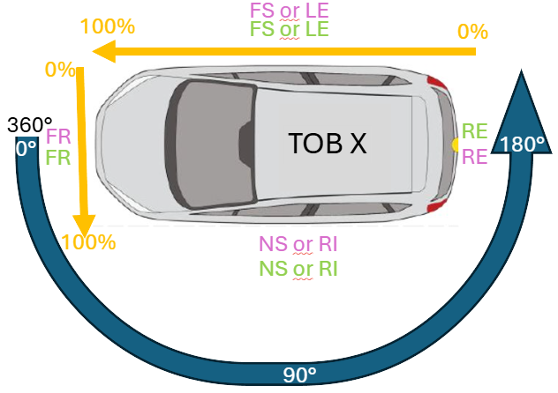
For non-vehicle targets with variable contour during test, the possible impact point is described as “GC” I addition with the impact side.
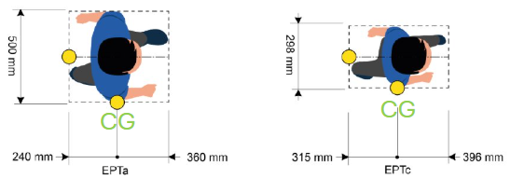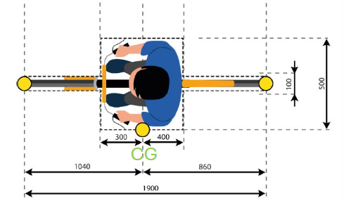

Robustness Layer
The robustness layer is to verify ADAS system performance on non ideal test conditions, but also under realistic and reproduceable variations.
Type | Robustness Layer Name | Code | Parameter | Example
None | Not applicable | NOVALUE | No robustness layer applied
VUT | Driver input pre-crash | DI
VUT | Impact location | IL | adjusted* impact location in %
Target | Speed | S | adjusted* target velocity in m/s | Variations in target speed
Target | Acceleration | A | adjusted* target acceleration in m/s2 | Variations in target acceleration
Target | Initial position offset | IP | adjusted* target position offset in m | Variations in starting point of test objects
Target | Trajectory/Heading | H | adjusted* target heading in ° | Variations in heading of test objects
Environment | Illumination (Nighttime) | N |  | night-time pedestrian detection
Environment | Illumination (Headlamp Glare) | HG |  | Oncoming headlights
Environment | Infrastructure/Clutter | I |  | Parked vehicle is in front of pedestrian path
Environment | Obscuration/Obstruction | O |  | Stationary pedestrian blocking view to walking pedestrian path
* Relative to the intended scenario parameter without the robustness layer applied: A robustness of 5km/h (= 1,39m/s) for target speed is written as “Robustness Layer: Target, S, -1.39”
Variation for values for robustness is according to following rules:
- Speed and acceleration reductions relative to the nominal scenario value are expressed as negative values.
- Smaller impact location values correspond to a shift of the impact location towards the beginning of the scale (0%).
- Heading variations follow the right-hand rule around the rotation axis. Positive values represent anti-clockwise rotations, while negative values represent clockwise rotations.

Reference Coordinate Systems
All channels are measured or calculated in specific reference coordinate systems. For MME 2.x the coordinate system Id is part of the extended channel code. The related reference system has to be agreed between the exchanging partners. The reference systems used in active safety tests can be reduced to the following table.
Id | Characteristic | Directions | Description | Remark
1DY | SV dynamic | X Y Z | Dynamic coordinate system  fixed to the SV according to ISO 8855 | Vehicle coordinate system according ISO 8855. Moving direction is X
2DY | Target dynamic | X Y Z | Dynamic coordinate system  fixed to the target according to ISO 8855 | Analog to a vehicle coordinate system according ISO 8855. Moving direction is X
1DF | SV dynamic with orientation fixed over TST | 1 2 3 | Dynamic coordinate system with orientation fixed to TST  fixed to the moving SV | Vehicle coordinate system based on 1DY on test start. Moving direction is 1
2DF | Target dynamic with orientation fixed over TST | 1 2 3 | Dynamic coordinate system with orientation fixed to TST  fixed to the moving target | Vehicle coordinate system based on 2DY on test start. Moving direction is 1
LOC | Steering Wheel | 1 2 3 | Local Coordinate system of the steering wheel  (1 = Longitudinal) | Only the rotation around the longitudinal axis of the steering system is used.
LOC | Path System | X Y Z | Local coordinate system of the path | Only the lateral deviation from the path is used.
NED | NorthEastDown | 1 2 3 | Stationary earth-fixed axis system  (1 = North, 2 = East, 3 = Down) | Typically from GPS based systems with units [m].
TST | Testground Static | X Y Z | Stationary earth-fixed axis system with an origin that is fixed in the ground plane | Derived from NED system by moving the origin to a point at the test ground and rotating the X axis to the main driving direction.

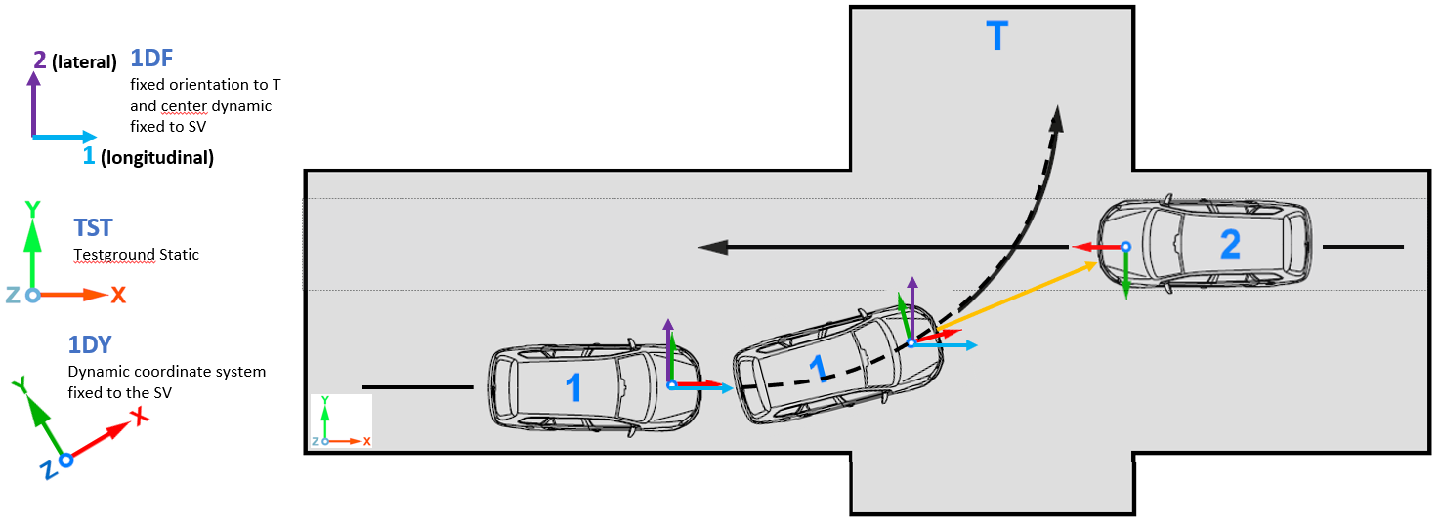
1DY and 2DY are right-hand coordinate systems according to ISO 8855, where: 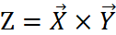.
The X and Y axes of the coordinate system are parallel to the ground plane, with the X and Y axis aligned with the vertical projection of the X_{V} and Y_{V} axis (vehicle axis) on to the ground plane.
The vehicle reference point is the point fixed in the vehicle sprung mass if no other point is explicit named. But this vehicle reference point may be defined in a variety of locations, based on the needs of the analysis or test: vehicle center of gravity, the sprung mass center of gravity, the mid-wheelbase point at the height of the center of gravity, and the center of the front axle.
1DF and 2DF are right-hand coordinate systems according to ISO 8855, where: . 1DF and 2DF are based on 1DY/2DY with fixed orientations of the axis to the initial direction over test ground. Despite all rotations of the test object over the test ground, the coordinate system maintains its orientation in X and Y.
In order to show that only longitudinal and lateral distances are determined, the directions 1, 2 and 3 are used.

Vehicle Coordinate System
The vehicle coordinate system is specified in ISO 855:2011. The origin of the coordinate system is located in the middle of the vehicle front. So the middle of the centerline is (0; 0; z), where z is specific to the vehicle height.
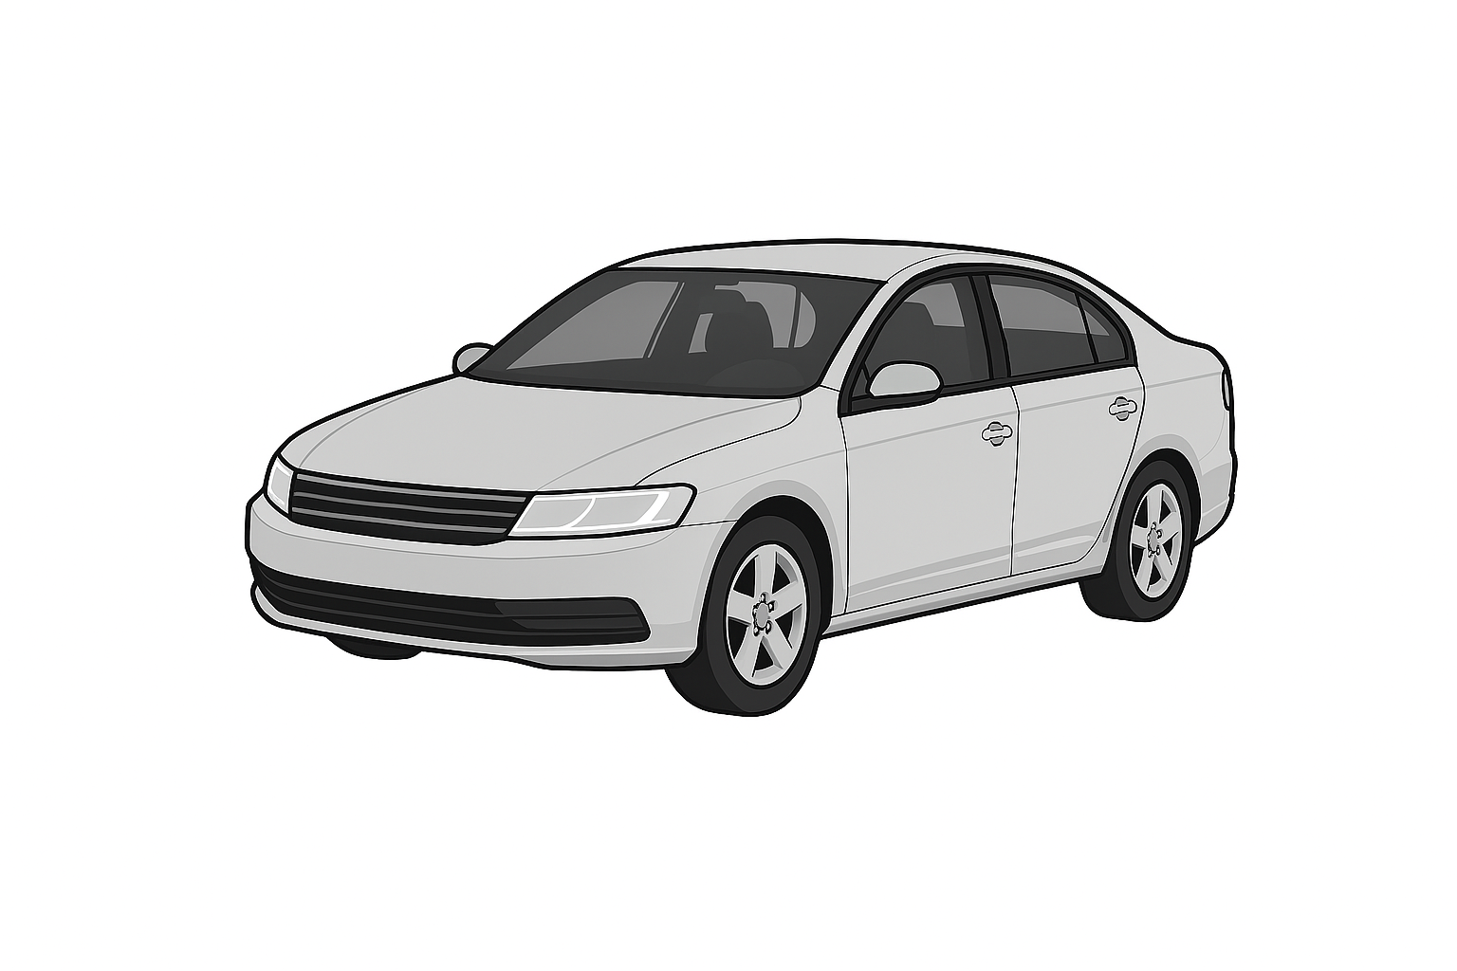
Z
Yaw ψ
X
Roll φ
Z
Pitch θ

Test Ground Coordinate System
The coordinate system of the test ground is a right-hand coordinate system where the x-axis is aligned with the initial direction of travel of the VUT. The y-axis is perpendicular to the x-axis.
The origin of this coordinate system is defined by scenario / type of test. This may be the expected collision point or the intersection between the projected paths of test objects.

Channel Codes
The channel code consists of 16 characters, composed of a sequence of codes with a fixed length and specific order, defining test object, position, main location, fine locations, physical dimension, direction and filter class

EXAMPLE | 1 0 VEHC 00 DI 00 VE X P
Meaning: | Test object | = 1 | Subject Vehicle
 | Position | = 0 | Undefined
 | Main location | = VEHC | The whole vehicle
 | Fine location 1 | = 00 | Undefined
 | Fine location 2 | = DI | Difference (relative)
 | Fine location 3 | = 00 | Undefined
 | Dimension | = VE | Velocity
 | Direction | = X | X-direction
 | Filter class | = P | Prefiltered
No filter classes are defined for active safety signals. Therefore all channels which could be filtered should have the filter class P (Prefiltered). Data sets which not could be filtered like Event or Time Channels should have the filter class 0. The filter class has to be S (Special) when Acceleration, Force or Angular Velocity Channels are filtered according to the specification given in the regulation.

Enhancement for specific Main and Fine Locations for active safety

Additional Main Locations
As ISO MME was focus on passive safety there were main location defined to describe parts of a vehicle. Active safety requires a more function based approach. For this purpose are the following main locations as specific extension defined.

Function based Main Locations
Main Location | Description
TTTC | AEB Time-to-Collision
TAEB | AEB activation time
TFCW | FCW activation time
TIMP | Impact time
TECS | Time where VUT enters in curve segment
TLKA | LKA activation time
TLDW | LDW activation time
TLCR | Line crossing time
TDOP | Time door opening
TRCT | Time Rear Crossing Traffic
THMS | Time Hold Management System
TABS | Time ABS status
TSAS | Time of Speed Limiter Action

Main Location for distances between test objects
Main Location | Description
DSOV | Distance SOV
DGVT | Distance GVT
DCOL | Collision Point distance
DLIN | Distance to Line
DINT | Distance to Intersection
DVUT | Distance to VUT
DIST | other Distance

Main Locations for Vulnerable Road Users
Test devices for targets, vulnerable road users and other objects are described in ISO 19206 Part 1, 2 and 4. Especially for vulnerable road users the number of different targets will grow in the future.
Here is a list of ISO Main Locations for these targets:
 | Group | Type | ISO ML code | Description | Comment
Animals | AN | MS | ANMS | Moose
Animals | AN | RO | ANRO | Roe
Animals | AN | WB | ANWB | Wild boar
Animals | AN | DR | ANDR | Deer
Animals | AN | HS | ANHS | Horse
Animals | AN | CW | ANCW | Cow
Animals | AN | DG | ANDG | Dog
Animals | AN | CT | ANCT | Cat
Animals | AN | BB | ANBB | Big Bird | walking Bird (e.g. Duck, Chicken, Goose,…)
Toys | TY | RC | TYRC | Ride-On Car | = e.g. Bobby Car
Toys | TY | RB | TYRB | Running Bike
Toys | TY | TC | TYTC | Tricycle
Toys | TY | SS | TYSS | Self-balancing Scooter | = e.g. Hoverboard or Hover Scooter
Two Wheeler | TW | CA | TWCA | Cyclist Adult
Two Wheeler | TW | CC | TWCx | Cyclist Child x years old | tbd: replace x by age when target is available
Two Wheeler | TW | EB | TWEB | Electric Cyclist / Pedelec | EuroNCAP target PTW
Two Wheeler | TW | MB | TWMB | Motorbike / PTW | EuroNCAP target PTW
Two Wheeler | TW | SC | TWSC | Scooter Adult | CNCAP e-Scooter or Motor scooter
Two Wheeler | TW | KS | TWKS | Kick Scooter | adult rider on (electric) kick scooter
Two Wheeler | TW | Kx | TWKx | Kick Scooter Child x years old | child rider on (electric) kick scooter  tbd: replace x by age when target is available
Two Wheeler | TW | SW | TWSW | Segway or similar
Two Wheeler | TW | WC | TWWC | Wheelchair
Pedestrian | PD | AD | PDAD | Adult / Adult Midsize 50%
Pedestrian | PD | AF | PDAF | Adult Female 5%
Pedestrian | PD | AL | PDAL | Adult Large 95%
Pedestrian | PD | Cx | PDCx | Child x years old | tbd: replace x by age when target is available
Pedestrian | PD | C1 | PDC1 | Child 1 year old | existing target PDCx
Pedestrian | PD | C2 | PDC2 | Child 2 years old | existing target PDCx
Pedestrian | PD | C7 | PDC7 | Child 7 years old | existing target PDCx
Pedestrian | PD | AW | PDAW | Adult Senior with 4-wheeled walker
Pedestrian | PD | BS | PDBS | Adult with baby stroller
Pedestrian | PD | SB | PDSB | Skateboarder
Pedestrian | PD | IS | PDIS | Inline Skater

Naming of Bus Signals
Bus signals can be named with the main location 2BUS.
Since many bus channels measure quantities that are also recorded by reference measurement technology, the main location of the measured quantity can be used with a specific value in the fine location 3. When bus signals are equivalent to named channels the code of the named channel with the Fine location 3 CB (car communication bus).

Additional Fine Locations

Fine Location 1
FL | long description | comment
WA | main warning signal | main warning signal as reaction for a system/function given by main location
PW | pre-warning signal | prewarning signal as reaction for a system/function given by main location
BE | braking event | breaking event as reaction for a system/function given by main location
PB | pre-braking event | prebreaking event as reaction for a system/function given by main location
ST | Status | current system status (e.g. on/off)
DC | dynamic calculation | Addition to TTTC for dynamic calculation of current speed/acceleration (für US-NCAP - Euro-NCAP assumes continuous travel) to determine a difference between EuroNCAP ("...would continue to travel with the speed it is travelling.") and US-NCAP (with acceleration)
PE | Path Error
SH | Shape
BX | Boundary Box
RC | Rotation Center
TY | Tyre
AX | Axle
EY | Eye-Position
DR | Door
BP | Bumper

Fine Location 2
FL | long description | comment
RQ | Requested | Indicator for Request on CAN bus or action request like "door opening interface"
SR | Switching Release | Indicator for Release of an switching request on CAN bus or action request
AC | acoustical | detection of accoustical signal
OP | optical | detection of optical signal

Fine Location 3
FL | long description | comment
CB | communication bus (e.g. CAN) | Analysis of channel via CAN bus signal and electric/optical measurement
SH | Shape
BX | Boundary Box
RC | Rotation Center
TY | Tyre
AX | Axle
EY | Eye-Position
DR | Door
BP | Bumper

Channel codes for function based channels

TTC
For calculation and evaluation the following channels are used for TTC:
- 10TTTC000000TI00 = TTC
- 10TTTCDC0000TI00 = TTC_with_Acc
As TTC is a calculated channel, the data is

If the laboratory decides to calculate TTC an add it to the data, the following channel codes are reserved:
- 101TTC000000TI00 = TTC
- 101TTCDC0000TI00 = TTC_with_Acc
The customer TTC channels are stored with main location 2TTC:
- 102TTC000000TI00 = TTC
- 102TTCDC0000TI00 = TTC_with_Acc

Calculated vs. vehicle communication bus channels
When measurement data is recorded on the the vehicle bus system, the channel is named according to the recorded size according to the naming scheme, with the letters CB for "communication bus" inserted at Fine Location 3.

Channel codes for distances
The most distances which must be known in active safety tests are between moving test objects and not located on one of these. There is a kneed to describe the involved test objects and also the used location on the test objects for each distance. So an enhancement for ISO codes is necessary.
The channel codes for distances between test object use TO, SP and FL1 to describe the first test object and FL2 and FL3 the second test object. The first object in this case is the test object, which is more important in this range: VUT, VRU, GVT, SOV.
TO | SP | ML | FL1 | FL2 | FL3 | Dimens. | Direct. | Filter | Description
1 | 2 | DGVT | MI | 22 | MI | DC | 1 | P | longitudinal distance of front middle VUT to front middle GVT
Fist TO |  |  | Fist TO | Second TO

FL2 is used for the second test object like the values TO+SP for the first test object.
TO | First/more important test Object (definition of VUT, GVT,… is in MME file)
SP | Location on first/more important test object (VUT, Target, GVT,…)
ML | Description of distance location
FL1 | location on first object (TO + SP) ( MI = middle; LE = left side without mirror; BX = Boundary Box; SH = Shape)
FL2 | TO + SP for second test object (e.g. 38 = TO3 (SOV) rear middle)
FL3 | location on second test object ( MI = middle; LE = left side without mirror; BX = Boundary Box; SH = Shape)
Dimens. | Dimension of the channel (for distances this will be DC)
Direct. | Direction of distance
Filter | Filter class

The following list shows all possible values for the positions in channel codes for distances:
TO | Versuchsobjekt /  test object |  |  | SP |  |  |  | ML
1 | VUT |  |  | 0 | undefiniert / overall |  |  | DSOV | Distance SOV
2 | GVT / Target |  |  | 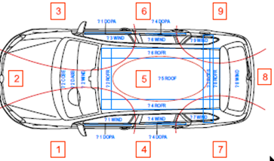 |  |  |  | DGVT | Distance GVT
3 | ggf. SOV |  |  |  |  |  |  | DCOL | Collision Point distance
X | running no. of Dummy |  |  |  |  |  |  | DLIN | Distance to Line
 |  |  |  |  |  |  |  | DINT | Distance to Intersection
 |  |  |  |  |  |  |  | DVUT | Distance to VUT
 |  |  |  |  |  |  |  | DIMP | Distance to impact point
 |  |  |  |  |  |  |  | DIST | other Distance
 |  |  |  |  |  |  |  | VEHC | vehicle

FL1 |  |  | FL2 | TO + SP for  GVT / SOV / Target | FL3
SH | Shape | VUT / GVT / SOV | 2x | GVT + descr. of SP of MME | SH | Shape | VUT / GVT / SOV
BX | Boundary Box | VUT / GVT / SOV | 3x | SOV + descr. of SP of MME | BX | Boundary Box | VUT / GVT / SOV
FR | Front | VUT / GVT / SOV | 21 | GVT front left | FR | Front | VUT / GVT / SOV
UP | Oben | VUT / GVT / SOV | 20 | VRU target | UP | Up | VUT / GVT / SOV
MI | Middle | VUT / GVT / SOV | … | … | MI | Middle | VUT / GVT / SOV
CG | Center of Gravity | VUT / GVT / SOV |  |  | CG | Center of Gravity | VUT / GVT / SOV
RC | Rotation Center | VUT / GVT / SOV | FL 2 | For Dummies:  No. Of test object + impact side | RC | Rotation Center | VUT / GVT / SOV
RE | Rear | VUT / GVT / SOV | FL 2 | For Dummies:  No. Of test object + impact side | RE | Rear | VUT / GVT / SOV
LE | Left | VUT / GVT / SOV | FL 2 | For Dummies:  No. Of test object + impact side | LE | Left | VUT / GVT / SOV
RI | Right | VUT / GVT / SOV | 22 | front | RI | Right | VUT / GVT / SOV
TY | Tyre | VUT / GVT / SOV | 24 | left side | TY | Tyre | VUT / GVT / SOV
AX | Axle | VUT / GVT / SOV | 20 | undef. | AX | Axle | VUT / GVT / SOV
EY | Eye-Position | VUT / GVT / SOV | 25 | nearest side to VUT | EY | Eye-Position | VUT / GVT / SOV
DR | Door | VUT / GVT / SOV |  |  | DR | Door | VUT / GVT / SOV
BP | Bumper | VUT / GVT / SOV |  |  | BP | Bumper | VUT / GVT / SOV
00 | undef. | VUT / GVT / SOV |  |  | 00 | undef. | VUT / GVT / SOV
 |  |  |  |  | FR | Front | Dummies
 |  |  |  |  | LE | Left | Dummies
 |  |  |  |  | RI | Right | Dummies
 |  |  |  |  | RE | Rear | Dummies
 |  |  |  |  | CG | Center | Dummies
 |  |  |  |  | IN | Inner | Line
 |  |  |  |  | OU | Outer | Line

Direction |  | coordinate system
0 | Undefined/other
1 | Longitudinal | 1DT
2 | Lateral | 1DT
3 | Vertical | 1DT
X | Longitudinal | 1DY
Y | Lateral | 1DY
Z | Vertical | 1DY
0 | Resultant
The coordinate system refers
to test object in TO

C2C distance channels

CCRs, CCRm, CCRb
12DGVTMI28MIDC1P – longitudinal Distance Front VUT- Back GVT
12DGVTMI28MIDC2P – lateral Distance Front VUT- Back GVT
12DGVTMI28REDCXP – Headway Distance Front VUT- Back GVT (in X)
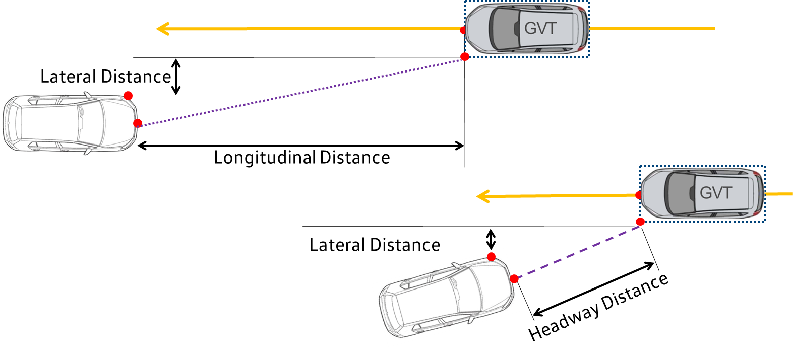

CCFtap
11DGVTSH21BXDC1P – C2C longitudinal Distance Front Shape VUT – GVT Box
11DGVTSH21BXDC2P – C2C lateral Distance Front Shape VUT – GVT Box
12DGVTMI20BXDCXP – C2C Headway Distance Front Shape VUT – GVT Box (in X)
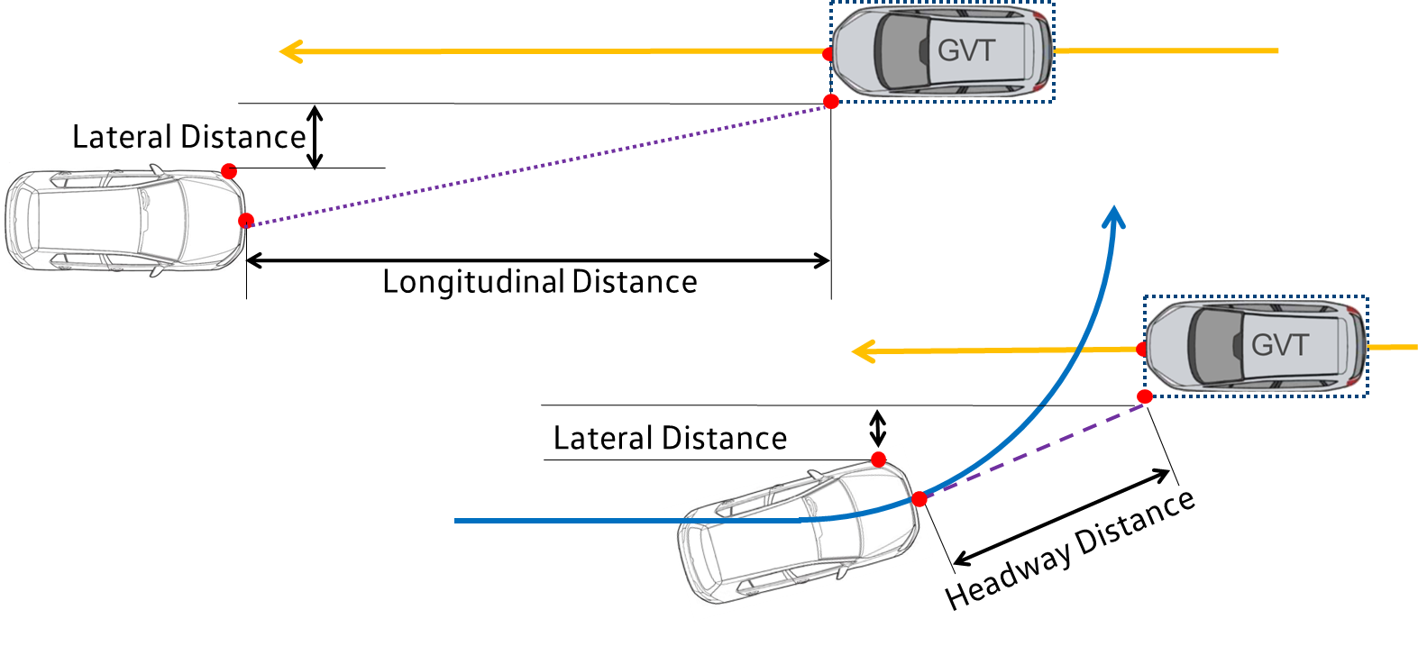

VRU distance channels

Nearside, Farside, Longitudinal
12DVUTSH20MIDC1P – VUT-VRU longitudinal Distance
(0 instead of 2/4/6/8 same code for nearside and farside)
12DVUTMI20MIDC2P – VUT-VRU lateral Distance
12DVUTMI20MIDC0P – VUT-VRU resultant distance
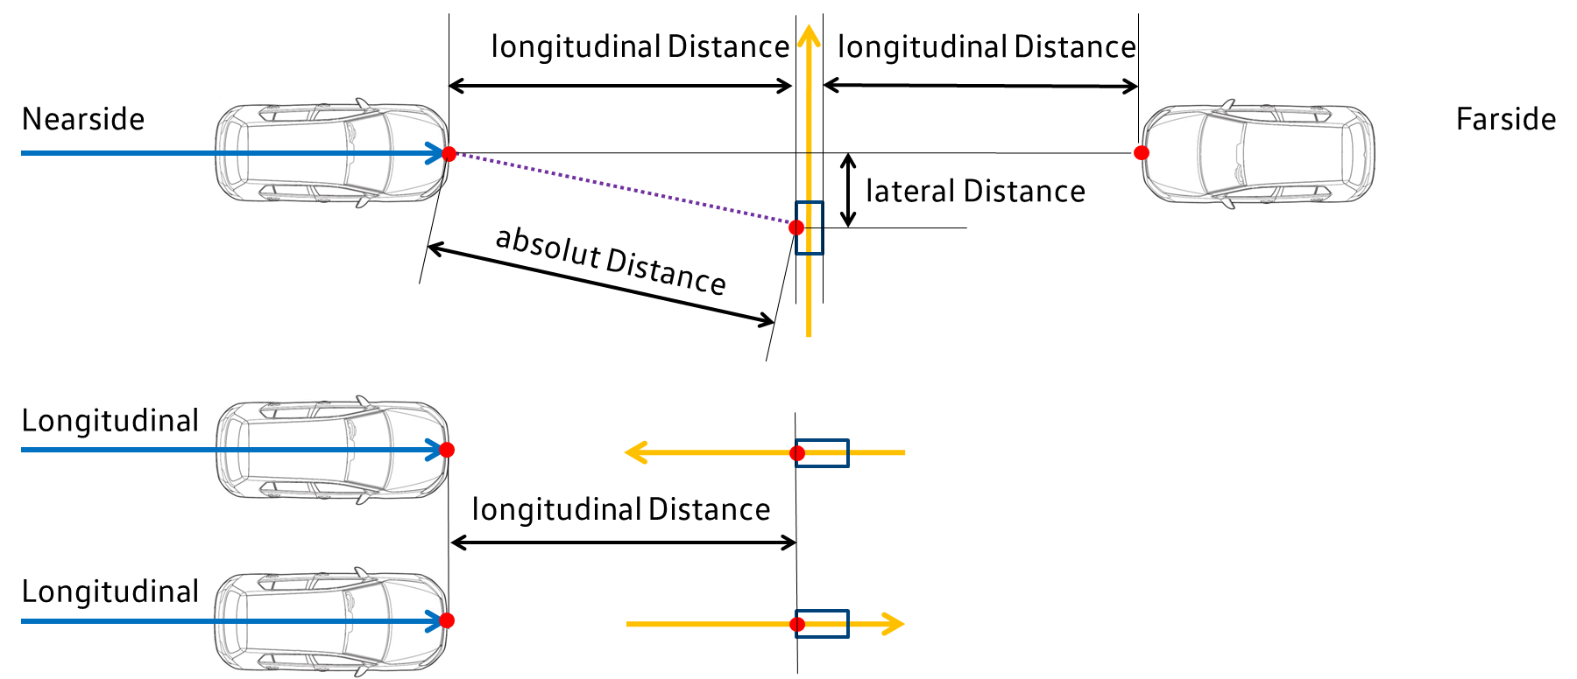

Turning, Reverse
12DVUTMI20MIDC1P – VRU longitudinal Distance
12DVUTMI20MIDC2P – VRU lateral Distance
12DVUTMI20MIDC0P – resultant distance
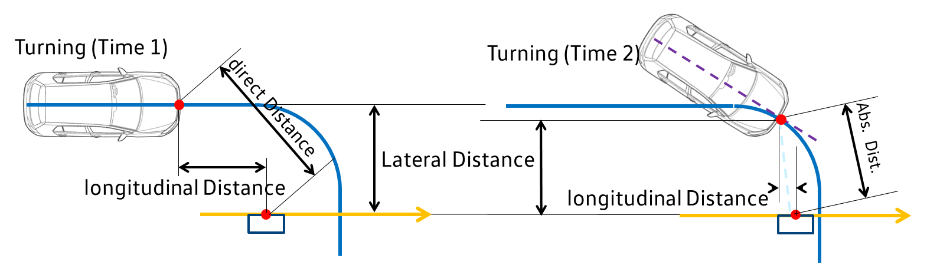
18DVUTMI20MIDC1P – VRU longitudinal Distance
18DVUTMI20MIDC2P – VRU lateral Distance
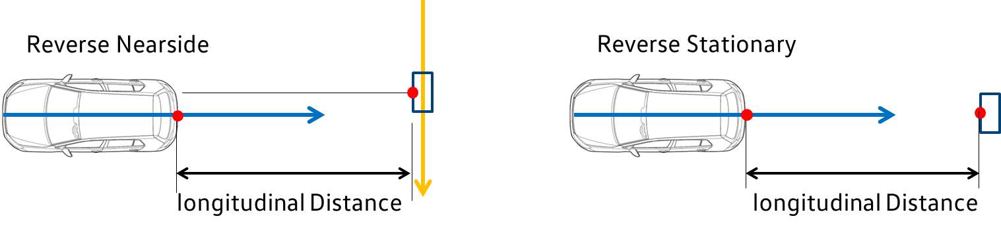

LSS distance channels
13DLINTY00INDC2P - lateral distance Tyre to line crossing (inner edge)
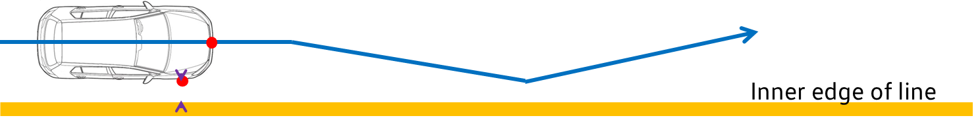

13DLINTY00OUDC2P - lateral distance Tyre to line crossing (outer edge)
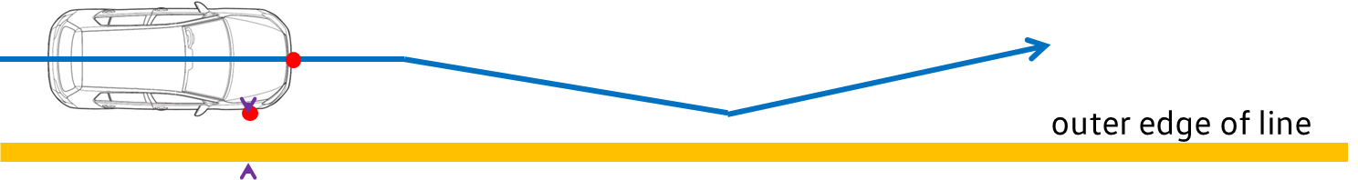

BSD distance channels

Overtaking
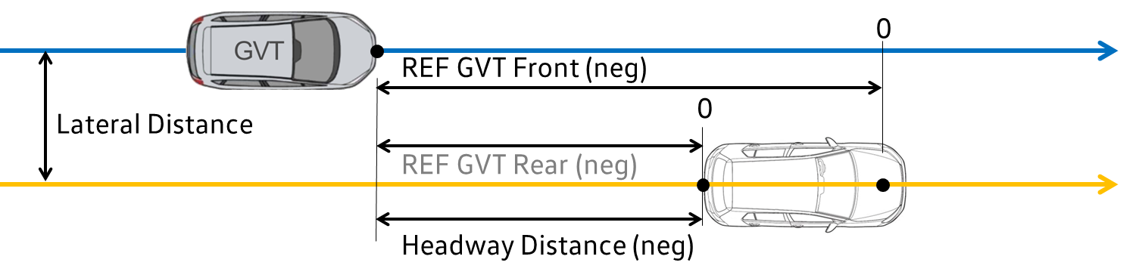

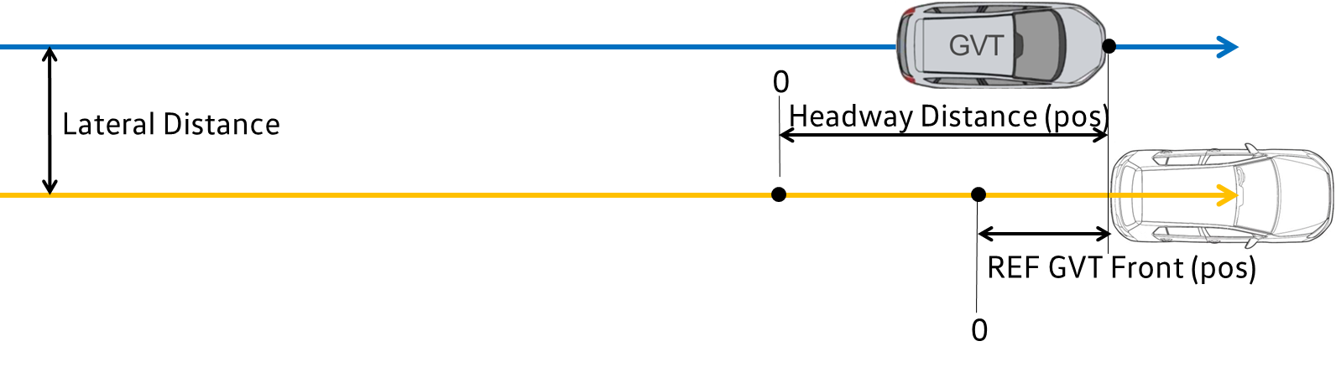

Merging

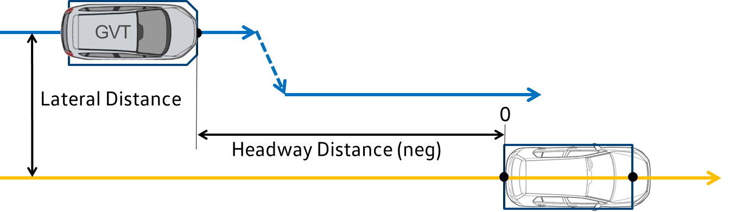

Path Error distance channels

VUT longitudinal path error
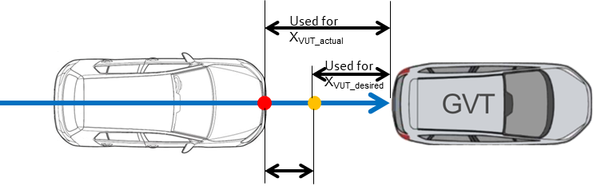
10VEHCPE0000DC1P = X_{VUT_desired} - X_{VUT_actual}
X_{VUT_actual}: actual X-Coordinate of middle front of the VUT
in relation to GVT
X_{VUT_desired}: desired X-Coordinate of middle front of the VUT
in relation to GVT

The longitudinal path error is the difference between actual distance VUT-GVT and desired distance VUT-GVT
*CCFtab+CMFtab: Instead of GVT a fixed point before the collision point is used:

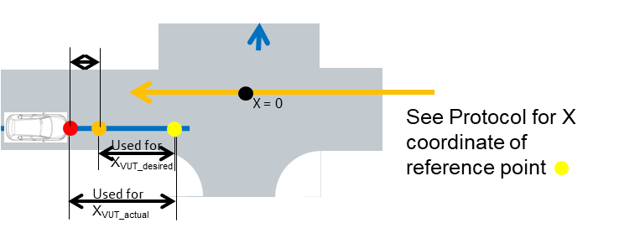

VUT lateral path error
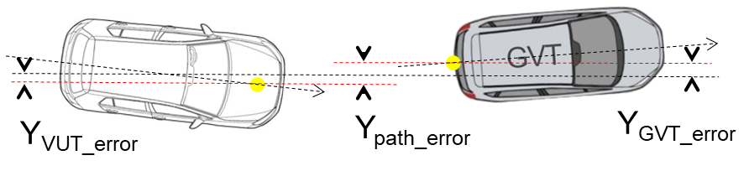
10VEHCPE0000DC2P = Y_{VUT_error} + Y_{GVT_error}

CMFtab: The path error is calculated by Y_{VUT_error}
10VEHCPE0000DC2P = Y_{VUT_error}

Examples
TO | SP | ML | FL1 | FL2 | FL3 | Dim. | Direct. | Filter | Description
1 | 2 | DGVT | MI | 22 | MI | DC | 1 | P | longitudinal distance of front middle VUT to front middle GVT
1 | 2 | DGVT | MI | 22 | MI | DC | 2 | P | lateral distance of front middle VUT to front middle GVT
1 | 2 | DGVT | MI | 22 | MI | DC | 0 | P | absolute distance of front middle VUT to front middle GVT
1 | 2 | DSOV | LE | 32 | LE | DC | 1 | P | longitudinal distance of front middle VUT to front middle SOV
1 | 4 | DSOV | LE | 34 | LE | DC | 2 | P | lateral distance of front middle VUT to front middle SOV
2 | 2 | DSOV | MI | 38 | MI | DC | 1 | P
1 | 3 | DLIN | TY | 00 | IN | DC | 2 | P | VUT tyre to inner side of line
1 | 3 | DLIN | TY | 00 | OU | DC | 2 | P | VUT tyre to outer side of line
1 | 2 | DGVT | MI | 28 | MI | DC | 1 | P | Headway distance (lateral)
1 | 2 | DGVT | MI | 28 | MI | DC | 2 | P | lateral Distance (Middle to Middle)
1 | 2 | DGVT | MI | 28 | RE | DC | X | P | Headwy distance in X
1 | 1 | DGVT | SH | 21 | BX | DC | 1 | P | CCFtab longitudinal distance
1 | 1 | DGVT | SH | 21 | BX | DC | 2 | P | CCFtab lateral distance
1 | 2 | DGVT | SH | 20 | BX | DC | X | P | CCFtab headway distance
1 | 2 | DCOL | MI | 00 | 00 | DC | 1 | P | longitudinal distance VUT middle to collision point
2 | 1 | DCOL | BX | 00 | 00 | DC | 0 | P | absolute distance GVT corner to collision point
1 | 2 | DVUT | SH | 20 | MI | DC | 1 | P | VUT-VRU longitudinal distance
1 | 2 | DVUT | MI | 20 | MI | DC | 2 | P | VUT-VRU lateral distance
1 | 2 | DVUT | MI | 20 | MI | DC | 0 | P | VUT-VRU absolut distance
1 | 2 | DGVT | SH | 20 | SH | DC | 1 | P | relative longitudinal distance
1 | 0 | DGVT | SH | 20 | SH | DC | 2 | P | relative lateral distance
1 | 1 | DVUT | DR | 20 | SH | DC | 1 | P | lateral distance upper corner door to target shape

Codes for Test Type C2C
A list of examples gives the following table.
Channel Code | Unit | RefSys | Description
10PEAC000000000P | 1 | LOC | Accelerator Pedal Relative Position
10PEAC00RW00000P | 1 | LOC | Accelerator Pedal Command
10PEBR000000DS0P | m | LOC | Brake Pedal Position
10PEBR000000FO0P | N | LOC | Brake Pedal Force
10PEBR00RW00000P | 1 | LOC | Brake Pedal Command
10STWL000000AV1P | rad/s | LOC | VUT Steering Wheel Angle Velocity
10STWL000000AN1P | rad | LOC | VUT Steering Wheel Angle
10STWL000000MO1P | Nm | LOC | VUT Steering Wheel torque
10TFCW000000EV00 | 1 | - | FCW acoustical
10TLDW000000EV00 | 1 | - | Curve entry event
10TTTC000000TI00 | s | - | TTC
10TTTC010000TI00 | s | - | TTC with Acceleration
10TURN000000EV00 | 1 | - | Turning Indicator Event
10VEHC000000ACXP | m/(s*s) | 1DY | VUT Longitudinal Acceleration
10VEHC000000AVZP | rad/s | 1DY | VUT Yaw Rate
10VEHC000000DSXP | m | TST | VUT Position X
10VEHC000000DSYP | m | TST | VUT Position Y
10VEHC000000VEXP | m/s | 1DY | VUT Longitudinal Velocity
10VEHC00DI00DCYP | m | LOC | VUT Lateral Path Error
10VEHC00DI00DSXP | m | 1DY | Headway Distance VUT - Target
10VEHC00DI00DSYP | m | 1DY | Lateral Distance VUT - Target
20VEHC000000ACXP | m/(s*s) | 2DY | Target Longitudinal Acceleration
20VEHC000000AVZP | rad/s | 2DY | Target Yaw Rate
20VEHC000000DSXP | m | TST | Target Position X
20VEHC000000DSYP | m | TST | Target Position Y
20VEHC000000VEXP | m/s | 2DY | Target Longitudinal Velocity
20VEHC000000VEYP | m/s | 2DY | Target Lateral Velocity
20VEHC00DI00DCYP | m | LOC | Target Lateral Path Error
…
Examples for the usage of bus signals:
10TTTCRD0000TI00 | s | - | Bus Signal TTC
10VEHCRD0000ACXP | m/(s*s) | 1DY | Bus Signal VUT Requested Acceleration
102BUS010000000P | 1 | - | Bus Signal 1 Raw
102BUS010000EV00 | 1 | - | Bus Signal 1
102BUS020000EV00 | 1 | - | Bus Signal 2
102BUS030000000P | 1 | - | Bus Signal 3 Raw
102BUS030000EV00 | 1 | - | Bus Signal 3
…

Codes for Test Type VRU
A list of examples gives the following table.
Channel Code | Unit | RefSys | Description
10PEAC000000000P | 1 | LOC | Accelerator Pedal Relative Position
10PEAC00RW00000P | 1 | LOC | Accelerator Pedal Command
10PEBR000000DS0P | m | LOC | Brake Pedal Position
10PEBR000000FO0P | N | LOC | Brake Pedal Force
10STWL000000AV1P | rad/s | LOC | VUT Steering Wheel Angle Velocity
10STWL000000AN1P | rad | LOC | VUT Steering Wheel Angle
10STWL000000MO1P | Nm | LOC | VUT Steering Wheel torque
10TFCW000000EV00 | 1 | - | FCW acoustical
10VEHC000000ACXP | m/(s*s) | 1DY | VUT Longitudinal Acceleration
10VEHC000000AVZP | rad/s | 1DY | VUT Yaw Rate
10VEHC000000DSXP | m | TST | VUT Position X
10VEHC000000DSYP | m | TST | VUT Position Y
10VEHC000000VEXP | m/s | 1DY | VUT Longitudinal Velocity
10VEHC00DI00DCYP | m | LOC | VUT Lateral Path Error
10VEHC00DI00DSXP | m | 1DY | Headway Distance VUT - Target
10VEHC00DI00DSYP | m | 1DY | Lateral Distance VUT - Target
20TWCA000000DSXP  20CYCL000000DSXP | m | TST | Cyclist Position X
20TWCA000000DSYP  20CYCL000000DSYP | m | TST | Cyclist Position Y
20TWCA000000VEXP  20CYCL000000VEXP | m/s | 2DY | Cyclist Longitudinal Velocity
20TWCA000000VEYP  20CYCL000000VEYP | m/s | 2DY | Cyclist Lateral Velocity
20TWCA00DI00DCYP  20CYCL00DI00DCYP | m | LOC | Cyclist Lateral Path Error
20TWCA000000ANYP  20CYCL000000ANYP | m | LOC | Cyclist Yaw Angle
20TWCA000000AVYP  20CYCL000000AVYP | m | LOC | Cyclist Yaw Velocity
20PDAD000000DSXP  20PEDA000000DSXP | m | TST | Pedestrian (adult) Position X
20PDAD000000DSYP  20PEDA000000DSYP | m | TST | Pedestrian (adult) Position Y
20PDAD000000VEXP  20PEDA000000VEXP | m/s | 2DY | Pedestrian (adult) Longitudinal Velocity
20PDAD000000VEYP  20PEDA000000VEYP | m/s | 2DY | Pedestrian (adult) Lateral Velocity
20PDAD00DI00DCYP  20PEDA00DI00DCYP | m | LOC | Pedestrian (adult) Lateral Path Error
20PDAD000000ANYP  20PEDA000000ANYP | m | LOC | Pedestrian (adult) Yaw Angle
20PDAD000000AVYP  20PEDA000000AVYP | m | LOC | Pedestrian (adult) Yaw Velocity
20PDC7000000DSXP 20PEDC000000DSXP | m | TST | Pedestrian (child) Position X
20PDC7000000DSYP  20PEDC000000DSYP | m | TST | Pedestrian (child) Position Y
20PDC7000000VEXP  20PEDC000000VEXP | m/s | 2DY | Pedestrian (child) Longitudinal Velocity
20PDC7000000VEYP  20PEDC000000VEYP | m/s | 2DY | Pedestrian (child) Lateral Velocity
20PDC700DI00DCYP  20PEDC00DI00DCYP | m | LOC | Pedestrian (child) Lateral Path Error
20PDC7000000ANYP  20PEDC000000ANYP | m | LOC | Pedestrian (child) Yaw Angle
20PDC7000000AVYP  20PEDC000000AVYP | m | LOC | Pedestrian (child) Yaw Velocity
20TWMB000000DSXP | m | TST | Motorcycle Position X
20TWMB000000DSYP | m | TST | Motorcycle Position Y
20TWMB000000VEXP | m/s | 2DY | Motorcycle Longitudinal Velocity
20TWMB000000VEYP | m/s | 2DY | Motorcycle Lateral Velocity
20TWMB00DI00DCYP | m | LOC | Motorcycle Lateral Path Error
20TWMB000000ANYP | m | LOC | Motorcycle Yaw Angle
20TWMB000000AVYP | m | LOC | Motorcycle Yaw Velocity
…
Examples for the usage of bus signals:
10TTTCRD0000TI00 | s | - | Bus Signal TTC
10VEHCRD0000ACXP | m/(s*s) | 1DY | Bus Signal VUT Requested Acceleration
102BUS010000000P | 1 | - | Bus Signal 1 Raw
102BUS010000EV00 | 1 | - | Bus Signal 1
102BUS020000EV00 | 1 | - | Bus Signal 2
102BUS030000000P | 1 | - | Bus Signal 3 Raw
102BUS030000EV00 | 1 | - | Bus Signal 3
…

Codes for Test Type LSS
A list of examples gives the following table.
Channel Code | Unit | RefSys | Description
10TLCR000000TI00 | s | - | TLC
10TLCRFRLE00EV00 | 1 | - | Line Crossing Time LHS
10TLCRFRRI00EV00 | 1 | - | Line Crossing Time RHS
10TLDW000000EV00 | 1 | - | LDW Activation Time
10TLDW010000EV00 | 1 | - | LDW Vibration
10TLKA000000EV00 | 1 | - | LKA Activation Time
10VEHC000000ACXP | m/(s*s) | 1DY | VUT Longitudinal Acceleration
10VEHC000000ACYP | m/(s*s) | 1DY | VUT Lateral Acceleration
10VEHC000000AVZP | rad/s | 1DY | VUT Yaw Rate
10VEHC000000DSXP | m | TST | VUT Position X
10VEHC000000DSYP | m | TST | VUT Position Y
10VEHC000000VEXP | m/s | 1DY | VUT Longitudinal Velocity
10VEHC000000VEYP | m/s | 1DY | VUT Lateral Velocity
10VEHC00DI00DCYP | m | LOC | Lateral Path Error VUT
10VEHC00DI00DSYP | m | 1DY | Lateral Displacement
11WHEL000000DSXP | m | TST | VUT Front Left Wheel Position X - needed?
11WHEL000000DSYP | m | TST | VUT Front Left Wheel Position Y - needed?
13WHEL000000DSXP | m | TST | VUT Front Right Wheel Position X - needed?
13WHEL000000DSYP | m | TST | VUT Front Right Wheel Position Y - needed?
20VEHC000000ACXP | m/(s*s) | 2DY | Target Longitudinal Acceleration
20VEHC000000AVZP | rad/s | 2DY | Target Yaw Rate
20VEHC000000DSXP | m | TST | Target Position X
20VEHC000000DSYP | m | TST | Target Position Y
20VEHC000000VEXP | m/s | 2DY | Target Longitudinal Velocity
…
Examples for the usage of bus signals:
10TLKARD0000000P | 1 | - | Bus Signal LKA Requested
10TLKARD0000EV00 | 1 | - | Bus Signal LKA Approval
10VEHCRDDI00DSYP | m | 1DY | Bus Signal Lateral Displacement
…

Codes for Test Type DOW
A list of examples gives the following table.
Channel Code | Unit | RefSys | Description
1?TDOP000000EV00 | 1 | - | Door opening interface SP X (Contact sensor)
1?TDOPWA0000EV00 | 1 | - | Door opening interface signal SP X
1?TDOPWA0200EV00 | 1 | - | Door opening warning acoustical SP X
1?TDOPWA0300EV00 | 1 | - | Door opening warning optical SP X

Examples

Examples for MME 1.6

Example of a test information file MME 1.6
Filename: 26C2C-123M.mme
Data format edition number :1.6
Laboratory name :NOVALUE
Laboratory contact name :NOVALUE
Laboratory contact phone :NOVALUE
Laboratory contact fax :NOVALUE
Laboratory contact email :NOVALUE
Laboratory test ref. number :26C2C-123M
Customer name :NOVALUE
Customer test ref. number :NOVALUE
Customer project ref. number:NOVALUE
Customer order number :NOVALUE
Customer cost unit :NOVALUE
Customer test engineer name :NOVALUE
Customer test engineer phone:NOVALUE
Customer test engineer fax :NOVALUE
Customer test engineer email:NOVALUE
Title :NOVALUE
Medium No./number of media :1/1
Timestamp :2026-07-11 08:41:35
Type of the test :C2C
Subtype of the test :CCRb_AEB
Regulation :EuroNCAP_C2C_2020
Scenario :CCRb
System Function :AEB
Test Campaign Type :C2C
Test Campaign Name :21C2C
Environment day light :day
Precipitation type :NOVALUE
Precipitation intensity :NOVALUE
Weather obstruction :NOVALUE
Weight of obstruction :NOVALUE
Wind speed :NOVALUE
Road surface temperature :NOVALUE
Sky conditions :NOVALUE
Road conditions :NOVALUE
Test completion :NOVALUE
Position of the sun :NOVALUE
Glare angle :NOVALUE
Reference temperature :NOVALUE
Relative air humidity :NOVALUE
Date of the test :11-07-2026 08:40:30
Type of data source :Physical Test
Region :EU
Robustness Layer :NOVALU
Run repetition :1
Number of test objects :2
Name of test object 1 :VUT
Velocity test object 1 :11.2
Mass test object 1 :NOVALUE
Driver position object 1 :NOVALUE
Impact side test object 1 :FR
Test function side 1 :FR
Type of test object 1 :1
Class of test object 1 :VUT
Code of test object 1 :NOVALUE
Ref. number of test object 1:NOVALUE
Velocity intended TOB 1 :11.1111
Velocity intended lat. TOB 1:0
Impact Location TOB 1 :50
Velocity lateral TOB 1 :0
Acceleration int. TOB 1 :NOVALUE
Acceleration int. lat. TOB 1:NOVALUE
Lane Departure Side TOB 1 :NOVALUE
Headway distance int. TOB 1 :12
Dist. Offset ini. Pos. TOB 1:NOVALUE
Time Offset ini. Pos. TOB 1 :NOVALUE
Intended Heading TOB 1 :0
Lane marking function line :NOVALUE
Lane marking secondary line :NOVALUE
Vel. int. lane dep. TOB 1 :NOVALUE
Distance eye to end TOB 1 :NOVALUE
Shape Front TOB 1 :(-0.9;-0.2) (-0.6;-0.1) (-0.3;-0.05) (0;0) (0.3;-0.005) (0.6;-0.1) (0.9;-0.2)
Shape Rear TOB 1 :(0.9;-3.910) (0.9;3.300) (0.9;2.800) (0.9;1.960) (0.9;1.340) (0.9;0.720) (0.9;-0.2)
Shape Right Side TOB 1 :(-0.9;-3.910) (-0.9;3.300) (-0.92.800y3) (-0.9;1.960) (-0.9;1.340) (-0.9;0.720) (-0.9;-0.2)
Shape Left Side TOB 1 :(-0.9;-3.910) (-0.6;-4.010) (-0.3;-4.110) (0;-4.210) (0.3;-4.110) (0.6;-4.010) (0.9;-3.910)
Dimensions TOB 1 :(4.210;1.820)
Front overhang TOB 1 :750
Driver State TOB 1 :NOVALUE
S/W version TOB 1 :V15
Name of test object 2 :GVT
Velocity test object 2 :0
Mass test object 2 :NOVALUE
Driver position object 2 :NOVALUE
Impact side test object 2 :RE
Type of test object 2 :2
Class of test object 2 :GVT
Code of test object 2 :NOVALUE
Ref. number of test object 2:NOVALUE
Velocity intended TOB 2 :11.1111
Velocity intended lat. TOB 2:0
Impact Location TOB 2 :50
Test function side 2 :
Velocity lateral TOB 2 :
Acceleration int. TOB 2 :NOVALUE
Acceleration int. lat. TOB 2:NOVALUE
Lane Departure Side TOB 2 :NOVALUE
Headway distance int. TOB 2 :NOVALUE
Dist. Offset ini. Pos. TOB 2:NOVALUE
Time Offset ini. Pos. TOB 2 :NOVALUE
Intended Heading TOB 2 :0
Lane marking function line :NOVALUE
Lane marking secondary line :NOVALUE
Vel. int. lane dep. TOB 2 :NOVALUE
Distance eye to end TOB 2 :NOVALUE
Shape Front TOB 2 :NOVALUE
Shape Rear TOB 2 :NOVALUE
Shape Right Side TOB 2 :NOVALUE
Shape Left Side TOB 2 :NOVALUE
Dimensions TOB 2 :NOVALUE
Front overhang TOB 2 :NOVALUE
Driver State TOB 2 :NOVALUE
S/W version TOB 2 :NOVALUE

Example of a channel information file MME 1.6
Filename: 21C2C-123M.chn
Instrumentation standard :NOVALUE
Number of channels :16
Name of channel 001 :10VEHC000000ACXP / VUT Longitudinal Acceleration
Name of channel 002 :10VEHC000000VEXP / VUT Longitudinal Velocity
Name of channel 003 :10VEHC000000VEYP / VUT Lateral Velocity
Name of channel 004 :10VEHC000000AVZP / VUT Yaw Rate
Name of channel 005 :10VEHC00DI00DCYP / Lateral path error VUT
Name of channel 006 :10STWL000000MO1P / VUT Steering Wheel Torque
Name of channel 007 :10TLDW000000EV00 / LDW Activation Time
Name of channel 008 :10TLKA000000EV00 / LKA Activation Time
Name of channel 009 :10VEHC00DI00DSYP / Distance Line - VUT Lateral
Name of channel 010 :11WHEL000000DSXP / VUT Front Left Wheel Position X
Name of channel 011 :11WHEL000000DSYP / VUT Front Left Wheel Position Y
Name of channel 012 :13WHEL000000DSXP / VUT Front Right Wheel Position X
Name of channel 013 :13WHEL000000DSYP / VUT Front Right Wheel Position Y
Name of channel 014 :20VEHC000000ACXP / GVT Longitudinal Acceleration
Name of channel 015 :20VEHC000000VEXP / GVT Longitudinal Velocity
Name of channel 016 :20VEHC000000AVZP / GVT Yaw Rate

Example of a channel data file MME 1.6
Filename: 21C2C-123M.008
Test object number :1
Data source :transducer
Data status :ok
Name of the channel :X-Position of the VUT
Laboratory channel code :10VEHC000000DSXP
Customer channel code :VUT Position X
Reference channel :implicit
Reference channel name :NOVALUE
Channel code :10VEHC000000DSXP
Channel frequency class :NOVALUE
Unit :m
Reference system :TST
Transducer type :NOVALUE
Pre-filter type :NOVALUE
Cut off frequency :NOVALUE
Channel amplitude class :NOVALUE
Sampling interval :0.01
Bit resolution :NOVALUE
Time of first sample :0.01
Number of samples :2406
Start offset interval :NOVALUE
End offset interval :NOVALUE
Offset post test :NOVALUE
Transducer id :NOVALUE
Transducer natural frequency:NOVALUE
Transducer damping ratio :NOVALUE
0.01
0.02
0.03
…

Examples for MME 2.1

Example of a test information file MME 2.1
Filename: 21C2C-123M.mme
Data format edition number :2.1
Timestamp :2021-04-14T06:41:35+02:00
Laboratory name :NOVALUE
Laboratory contact name :NOVALUE
Laboratory contact phone :NOVALUE
Laboratory contact fax :NOVALUE
Laboratory contact email :NOVALUE
Laboratory test ref number :21C2C-123M_CARID_20210414_145239
Customer name :NOVALUE
Customer test ref number :NOVALUE
Customer project ref number :NOVALUE
Customer order number :NOVALUE
Customer cost unit :NOVALUE
Customer contact name :NOVALUE
Customer contact phone :NOVALUE
Customer contact fax :NOVALUE
Customer contact email :NOVALUE
Title :NOVALUE
Type of the test :C2C
Subtype of the test :CCRs_AEB
Regulation :EuroNCAP_C2C_2020
Reference temperature :NOVALUE
Relative air humidity :NOVALUE
Date of the test :12-04-2021
Number of test objects :2
#Begin of testobjects
Type :1
Filename :21C2C-123M_1.mmi
#End of testobject
#Begin of testobject
Type :2
Filename :21C2C-123M_2.mmi
#End of testobject

Examples of object information files MME 2.1
Filename: 21C2C-123M_1.mmi
Name :VUT
Velocity :4.17
Mass :NOVALUE
Driver position :NOVALUE
Impact side test :FR
Class :SV
Code :NOVALUE
Ref number :NOVALUE
Offset :NOVALUE

Filename: 21C2C-123M_2.mmi
Name :GVT
Velocity :0
Mass :NOVALUE
Driver position :NOVALUE
Impact side test :NOVALUE
Class :VT
Code :NOVALUE
Ref number :NOVALUE
Offset :NOVALUE

Example of a channel information file MME 2.1
Filename: 21C2C-123M_Channel.mmi
Number of channels :16
Data origin :T
#Begin of channel
Extended channel code :10VEHC000000ACXP_1DYT
Channel code :10VEHC000000ACXP
Reference system id :1DY
#End of channel
#Begin of channel
Extended channel code :10VEHC00DI00DCYP_LOCT
Channel code :10VEHC00DI00DCYP
Reference system id :LOC
#End of channel
#Begin of channel
Extended channel code :10VEHC00DI00DSXP_1DYT
Channel code :10VEHC000000DSXP
Reference system id :1DY
#End of channel
#Begin of channel
Extended channel code :10VEHC000000DSXP_TSTT
Channel code :10VEHC000000DSXP
Reference system id :TST
#End of channel
#Begin of channel
Extended channel code :10VEHC000000DSYP_TSTT
Channel code :10VEHC000000DSYP
Reference system id :TST
#End of channel
…

Example of a channel data file MME 2.1
Filename: 21C2C-123M_10VEHC000000DSXP_TSTT.mmd
Data structure :Channel
Instrumentation standard :NOVALUE
Data source :transducer
Data status :ok
Unit :m
Name of the channel :10VEHC000000DSXP
Laboratory channel code :10VEHC000000DSXP
Customer channel code :VUT Position X
Reference channel :implicit
Reference channel name :NOVALUE
Uuid :NOVALUE
Transducer type :NOVALUE
Transducer id :NOVALUE
Transducer natural frequency:NOVALUE
Transducer damping ratio :NOVALUE
Calibration date :NOVALUE
Calibration due date :NOVALUE
Bit resolution :NOVALUE
Cut off frequency :NOVALUE
Channel frequency class :Prefiltered
Channel amplitude class :NOVALUE
Prefilter type :NOVALUE
Sampling interval :0.01
Time of first sample :0.01
Number of samples :2406
Start offset interval :NOVALUE
End offset interval :NOVALUE
Offset post test :NOVALUE
#Start of data
0.01
0.02
0.03
…

